Building an E-Commerce Multi-Agent AI Application Using LangGraph

Introduction
- In this section, we will build a real-world E-Commerce Multi-Agent AI Application using the LangGraph framework and deploy it on AWS.
- Rather than relying on a single AI model to handle every customer request, this application uses multiple specialized AI agents that collaborate to deliver an intelligent shopping experience.
- By understanding the customer’s intent, the system can recommend products, place orders, or track existing orders automatically.

Business Use Case
- Imagine an online shopping platform called AnyCart that provides customers with an AI-powered shopping assistant.
- When a shopper visits the website, they can interact with the AI assistant through a conversational chat interface instead of navigating through multiple pages.
Customers can ask questions such as:
- “What type of shoes do you have?”
- “Order running shoes with Product ID 101.”
- “Track my order.”
The AI assistant understands the customer’s request and routes it to the appropriate business function automatically.
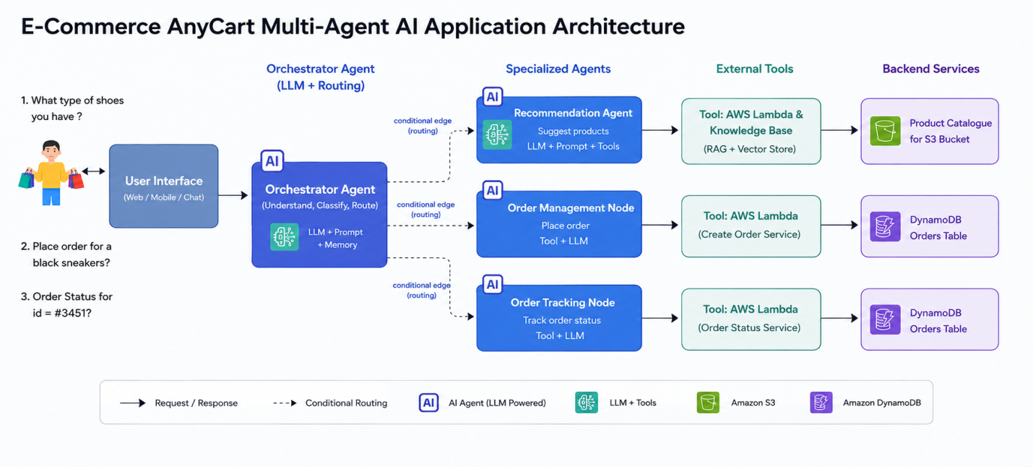

Customer Journey
- The shopping experience begins when a customer visits the AnyCart website and submits a request through the chat interface.
The request could involve:
- Finding product recommendations
- Purchasing a product
- Tracking an existing order
- Instead of treating every request the same way, the application first identifies the user’s intent before deciding what action to perform.
- This intelligent routing makes the interaction more natural and significantly improves the customer experience.

Intent Recognition
- At the heart of the application is an AI agent powered by a Large Language Model (LLM).
- Its first responsibility is to understand what the customer actually wants.
- Depending on the user’s request, the agent routes the conversation to one of several specialized AI agents.
For example:

Product Recommendation
- If the customer wants product suggestions, the request is routed to the Product Recommendation Agent.
- This agent searches the product catalog and recommends suitable products based on the customer’s query.

Order Placement
- If the customer wants to purchase an item, the request is forwarded to the Order Management Agent.
- This agent validates the product information, creates a new order in the backend database, and returns a unique Order ID to the customer.

Order Tracking
- If the customer wants to check the status of an existing order, the request is handled by the Order Tracking Agent.
- The agent retrieves the latest order information from the backend system and provides the current order status.

Multi-Agent Workflow
The complete workflow follows a simple but powerful sequence:
- The customer submits a request through the chat interface.
- The primary AI agent analyzes the user’s intent.
- The request is routed to the appropriate specialized AI agent.
- The selected agent performs the required business operation.
- The response is returned to the customer.
This architecture allows each AI agent to focus on a single responsibility while working together as a coordinated multi-agent system.

Core Business Capabilities
- The AnyCart Multi-Agent AI application provides three primary capabilities:

Product Recommendations
- The AI assistant searches the product catalog and recommends products that match the customer’s requirements.

Order Placement
- Customers can purchase products directly through natural language conversations without manually navigating the website.

Order Tracking
- Customers can check the status of previously placed orders using their Order ID.

Building the Application with LangGraph
- we will use LangGraph, one of the most widely adopted open-source Agentic AI frameworks.
- LangGraph enables developers to build applications where multiple AI agents collaborate, communicate, and execute complex workflows while maintaining conversational context.
- Using LangGraph, we will implement the complete AnyCart shopping assistant and deploy it on AWS.

Product Recommendation Example
- Suppose a customer asks:
“What type of shoes do you have?”
- The AnyCart Shopping Assistant responds by searching the product catalog and retrieving all available shoe products.
- Rather than generating an answer from memory, the AI agent queries the backend product catalog and presents the available inventory to the customer.

Placing an Order
- After reviewing the available products, the customer decides to purchase a pair of running shoes.
The customer submits the following request:
“Please order the running shoes with Product ID 101, quantity 2.”
The LangGraph workflow performs the following steps automatically:
- Understands the customer’s intent.
- Identifies that this is an order placement request.
- Calls the backend order service.
- Creates a new order.
- Generates a unique Order ID.
- Returns the Order ID to the customer.
All of these actions occur through a natural language conversation without requiring the customer to navigate multiple checkout screens.

Tracking an Existing Order
- A few days later, the customer wants to check the status of the order.
The customer asks:
“What is the status of Order ID 12345?”
The AI assistant immediately recognizes this as an order-tracking request.
The workflow retrieves the latest information from the backend database and returns details such as:
- Order ID
- Current order status
- Quantity ordered
For example:
- Order ID: 12345
- Status: Pending
- Quantity: 2
This creates a seamless conversational shopping experience for the customer.

Why LangGraph?
- LangGraph has become one of the most important Agentic AI frameworks used across modern enterprises.
Its key strengths include:
- Multi-agent workflow orchestration
- Stateful conversations
- Intelligent routing between agents
- Tool integration
- Backend system connectivity
- Scalable enterprise architecture
These capabilities make LangGraph an ideal choice for building intelligent business applications such as customer support systems, shopping assistants, and enterprise automation platforms.

